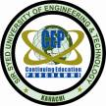**Sir Syed University of Engineering & Technology**

**Continuing Education Programme**

**University Road, Karachi-75300. Phone# 92 21 34800420; Fax# 92 21 34982393**

E-mail:- **cep@ssuet.edu.pk**; Website: - **http://www.ssuet.edu.pk/cep**

***Building Intelligent Serverless Container Based Cloud Apps with Python, Keras, TensorFlow, Flask, Docker***

*DataDevOps Specialist = Data Science + Software Developer + Operations*

**CERTIFICATE IN Data Science and**

**AI App Development**

A datascience Program DEsigned for absolute beginners

getting you ready for the new era of computing enabled by the rise of artificial intelligence (AI), Serverless Cloud Computing AND microservices.

now anyone can join the fourth industrial revolution

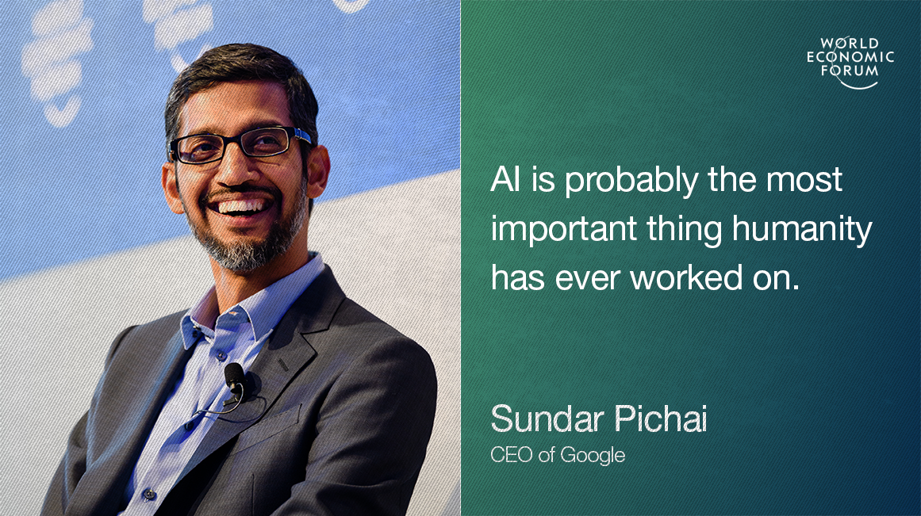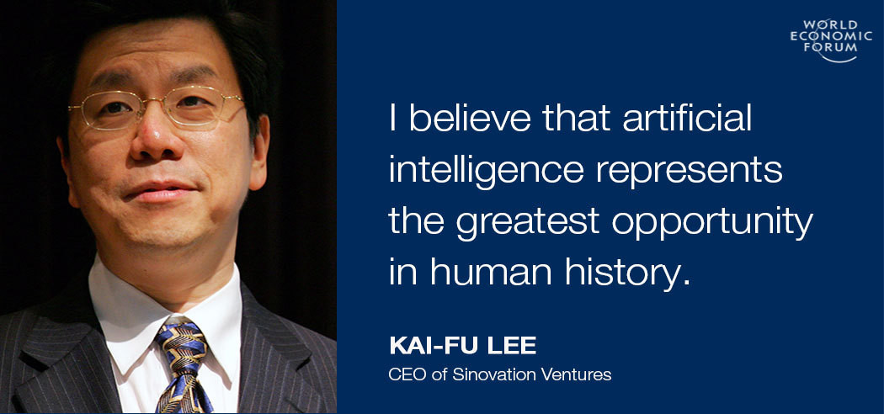

***Free Seminar 2:00 pm, Sunday, July 1, 2018***

***A Two-Semester Course, Classes only on Sundays***

***Questions?***

Machine learning and deep learning represents a key evolution in the fields of computer science, data analysis, software engineering, and artificial intelligence. Some commentators are calling AI the fourth industrial revolution. Others are calling it the new electricity. An incredible amount of money is pouring into companies focused on AI/ML and Data Science, as it has the potential to revolutionize most, if not all industries. In the next decade, more than 50% of jobs in the world will be replaced by AI, ranging from translators, editors, assistants, stock traders, securities, drivers, salespeople, customer service reps, accountants, nannies and so on. Continuing Education Programme is extremely pleased to announce a two-semester certificate course covering deep learning and data science. This program will teach you how to become a machine-learning engineer and data scientist using Python, Anaconda, Keras, and Tensorflow, and apply predictive models to massive data sets in fields like finance, healthcare, education, and more.

This program marks the beginning of the end of the data scientist and/or software engineer as disparate roles. Like DevOps has merged operations and development, DataDevOps will consume data science.

The classes and labs will be held on Sundays only. It will introduce you to the [Machine Learning Engineer Nanodegree](https://www.udacity.com/course/machine-learning-engineer-nanodegree--nd009) awarded by Google and Udacity and [Microsoft Professional Program Certificate in Data Science](https://academy.microsoft.com/en-us/professional-program/data-science/) and help you to take the first steps in becoming an expert in this cutting edge and highly in demand field.

The course does not require any background in software development or statistics anyone can join. In addition, it is also a ground-breaking course for Mobile, Web and IoT App developers that will allow them to build intelligent and the state-of-the-art apps in the fields like finance, healthcare, education, computer vision, automatic speech recognition, natural language processing, audio recognition, bioinformatics, internet of things and many other areas. In this course, you’ll develop a clear understanding of the motivation for deep learning, and design intelligent systems that learn from complex and/or large-scale datasets.

Google, Microsoft, and Amazon, have all been heavily investing in Artificial Intelligence (AI). Recently, each has launched new enterprise-scale AI-as-a-Service and APIs that will allow an average developer to build smart and intelligent apps. This is the dawn of a new era in computing.

The “Google Brain” team has revolutionized the artificial intelligence (AI) industry by developing TensorFlow, the latest and greatest deep learning library. It is one of the fastest-growing and most exciting fields out there. The library runs both on the mobile as well as in the cloud. TensorFlow can run on multiple CPUs and GPUs. It runs on server systems, as well as on mobile computing platforms, including Android and Apple's iOS.

Once you’ve trained machine learning models on your data, but how do you put them into production? When you have tens of thousands of model versions, each written in any mix of frameworks and exposed as REST API endpoints? This course explains why AI and machine learning are a natural fit for serverless containers and cloud computing —a general architecture for scalable and microservices based machine learning in production. The goal of this course is to teach you to build and deploying AI applications as easily as creating a website.

The course consists of two semesters of coursework.

**Fee: Rs. 6,000 per Semester (The duration of the course is two semesters).**

**Classes only on Sundays.**

**Semester AI 201**

AI in Practice and Microservices

Class on Sunday: 4:30 pm to 7:00 pm

**A Two-Semester AI Program in Data Science, Machine Learning, and Deep Learning**

**Semester AI 101**

Deep Learning with Python

Class on Sunday: 1:30 pm to 4:00 pm

If interested and have any Questions Join:

<https://www.facebook.com/groups/deep.learning.edu/>

**AI 101: Deep Learning with Python**

**Module A: Version Control with Git**

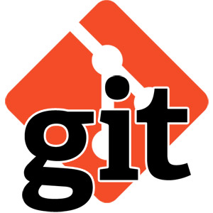 You won't find a top programmer, web developer, or AI enginner who doesn't use version control. Because it helps you produce better results and makes collaboration easy. Around the world, in teams large and small, Git is an essential part of the tool chain. We will start learning our learning process by covering Git and Github.

**Module B: Object Oriented and Functional Programming using Python**

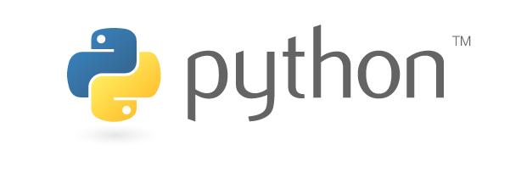In the second module of the course, you'll learn about basic programming concepts, such as lists, dictionaries, classes, functions and loops, and practice writing clean and readable code with exercises for each topic. You'll also learn how to make your programs interactive and how to test your code safely before adding it to a project. It is a fast-paced, thorough introduction to programming with Python 3.6 that will have you writing programs, solving problems, and making things that work in no time. In this module we will also learn Git, the distributed version control system. We will also review Git based GitHub and BitBucket services.

**Module C: Advanced Python Libraries with Anaconda**

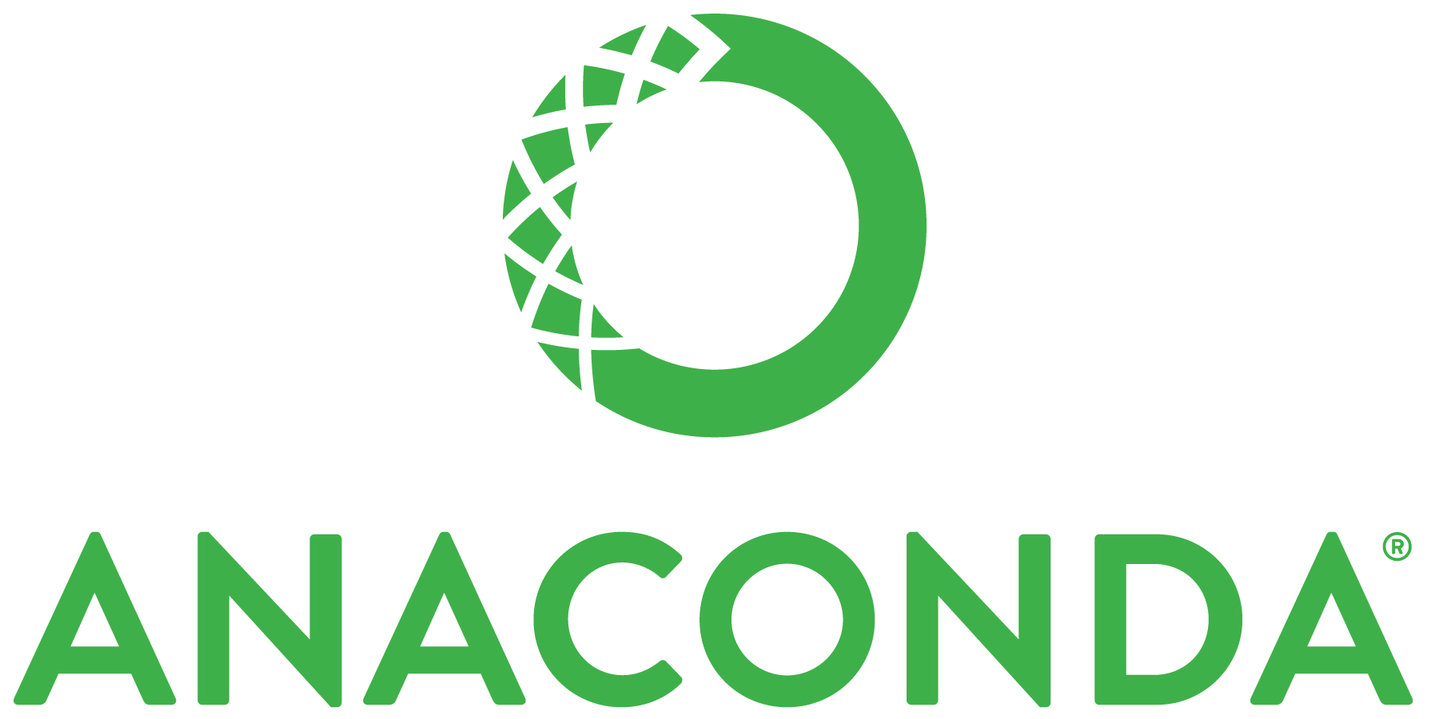In this module we will also introduce you to Anaconda which is the leading open data science platform powered by Python. The open source version of Anaconda is a high performance distribution of Python and R and includes over 100 of the most popular Python, and R packages for data science, such as NumPy, and Matplotlib, etc.

**Module D: Data Science Essentials**

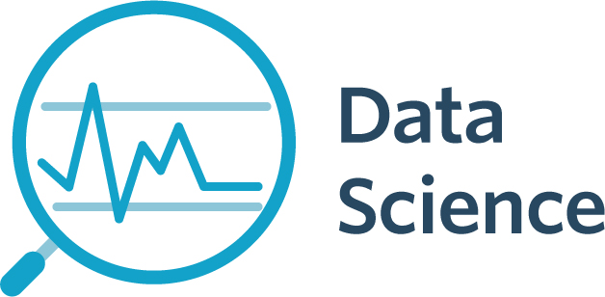Learn key concepts and techniques used to perform data science; including statistical analysis, data cleansing and transformation, and data visualization with Python.

**Module E: Introduction to Linear Algebra and Statistics**

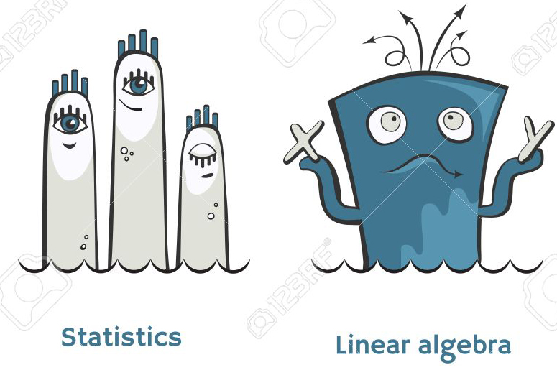

In this part of the course we will introduce the basic mathematical and statistical concepts that are needed to practice data science and understand deep learning. We will also implement these concepts in Python and TensorFlow.

**Module F: The Fundamentals of Deep Learning with Keras with TensorFlow Backend**

Before implementing deep-learning algorithms, we will first familiarize ourselves with mathematical blocks of neural networks theory. We going to start by geting our hands dirty writing some simple Keras code right away! And then move on to advanced deep learning concepts. This module will also cover some essential advantages of Keras to convince you it’s the deep-learning library of choice.

**Detailed Course Outline Semester AI 101:**

|  |  |  |
| --- | --- | --- |
| **Week** | **Topic** | **Learning Material** |
| 1-2 | Introduction to Data Science | <https://www.youtube.com/watch?v=z1kPKBdYks4>  Data Science for Beginners (5 Videos): <https://docs.microsoft.com/en-gb/azure/machine-learning/studio/data-science-for-beginners-the-5-questions-data-science-answers>  Homework (Complete the following course):  <https://cognitiveclass.ai/courses/data-science-101/> |
|  | Build Intelligent Apps: AI as Microservices | <https://wikibon.com/building-ai-microservices-for-cloud-native-deployments/>  https://jaxenter.com/machine-learning-interview-reichhelm-138821.html |
|  | What is DevOps and DataDevOps | <https://www.sdxcentral.com/articles/news/kubeflow-project-tacks-machine-learning-on-top-of-kubernetes/2017/12/>  <http://container-solutions.com/tensorflow-on-kubernetes-kubeflow/> |
| 3 | Version Control with Git | Chapters 1, 2, and 3, Learn Version Control with Git: A step-by-step course for the complete beginner by Tobias Günther  <https://www.datacamp.com/courses/introduction-to-git-for-data-science> |
| 4 | Getting Started with Python | A Smarter Way to Learn Python: Learn it faster. Remember it longer by Mark Myers  <https://www.amazon.com/Smarter-Way-Learn-Python-Remember/dp/1974431479> |
|  | Variables and Simple Data Types |  |
| 5 | Introducing Lists |  |
|  | Working with Lists |  |
| 6 | If Statements |  |
|  | Dictionaries |  |
| 7 | User Input and while loops |  |
|  | Functions |  |
| 8 | Classes |  |
|  | Files and Exceptions | **Complete 1-6 Python Assignments** |
| 9 | Sorting, List Comprehensions, Generators and Iterators, and Randomness | Chapter 1 & 2, Data Science from Scratch by Joel Grus |
| 10 | Functional Tools, enumerate, zip and Argument Unpacking, and args and kwargs, | Chapter 2, Data Science from Scratch by Joel Grus |
| 11 | Visualizing Data | Chapter 3, Data Science from Scratch by Joel Grus  **Quiz One: Python**  **Project:** <https://www.dropbox.com/s/wymvo1vcw0tcz4q/visualizing%20crypto%20prices.docx?dl=0>  Appear in **Microsoft Exam 98-381 Introduction to Programming Using Python**  <https://www.microsoft.com/en-us/learning/exam-98-381.aspx>  **Project 1:** <https://www.dropbox.com/s/gfxnrfhbosdwvcw/calculating%20beta.docx?dl=0>  **Project 2:**  <https://www.dropbox.com/s/sebhqixn3q9pe6h/Markowitz%20portfolio%20optimization.docx?dl=0>  **Project 3:**  https://www.dropbox.com/s/hr3ygqx0mkgwfxq/Cryptocurrency%20Arbitrage%20Finding%20Mismatched%20Prices.docx?dl=0 |
| 12 | Basics of Linear Algebra for Machine Learning | <https://machinelearningmastery.com/linear_algebra_for_machine_learning/>  Lesson 01: Introduction to Linear Algebra  Lesson 02: Linear Algebra and Machine Learning  Lesson 03: Examples of Linear Algebra in Machine Learning |
| 13 | NumPy Fundamentals | <https://machinelearningmastery.com/linear_algebra_for_machine_learning/>  Lesson 04: Introduction to NumPy Arrays  Lesson 05: Index, Slice, and Reshape NumPy Arrays  Lesson 06: NumPy Array Broadcasting  **Quiz Two: Numpy Quiz** |
| 14 | Statistics and Regression | Chapter 5, Data Science from Scratch by Joel Grus |
| 15 | What is Deep Learning? | Chapter 1, Deep Learning with Python by François Chollet  **Quiz Three: Deep Learning 1**  [**https://www.youtube.com/watch?v=aircAruvnKk**](https://www.youtube.com/watch?v=aircAruvnKk)  <https://www.youtube.com/watch?v=uXt8qF2Zzfo> |
| 16 | The mathematical building  blocks of neural networks | Chapter 2, Deep Learning with Python by François Chollet  **Quiz Four: Deep Learning 2** |
| 17 | Getting started with neural networks | Chapter 3, Deep Learning with Python by François Chollet  **Quiz Five: Deep Learning 3** |
| 18 | Fundamentals of  machine learning | Chapter 4, Deep Learning with Python by François Chollet  **Quiz Six: Deep Learning 4** |
|  |  | Four Projects:  Binary Classification Sonar Project 1 for the Navy: Mines vs. Rocks  <https://www.dropbox.com/s/v5xvykxmmbnagpc/Deep_Learning_Project_One.zip?dl=0>  Multi-Class Classification Iris Flowers Project 2 for Mothers who love Gardening and Flowers: Identifying Flower Types  <https://www.dropbox.com/s/ume0f03g9hdovdl/Deep_Learning_Project_Two.zip?dl=0>  Regression Housing Pricing Project 3 for Fathers who want to buy a House: Predicting Housing Prices  <https://www.dropbox.com/s/m98hfdo615t0z43/Deep_Learning_Project_Three.zip?dl=0>  Dropout Regularization Sonar Project 4 for the Navy: Mines vs. Rocks  <https://www.dropbox.com/s/s6h1ksnmfxukl7k/Deep_Learning_Project_Four.zip?dl=0> |

**Semester AI 201: AI in Practice and Microservices**

**Module A: Docker Deep Dive**

This course provides a soup-to-nuts learning experience for core Docker technologies, including the Docker Engine, Images, Containers, Registries, Networking, Storage, and more. All of the behind the scenes theory is explained, and all concepts are clearly demonstrated on the command line. No prior knowledge of Docker or Linux is required.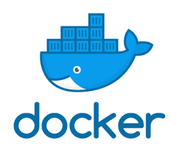

**Module B: Python Serverless Container Based Microservices Development**

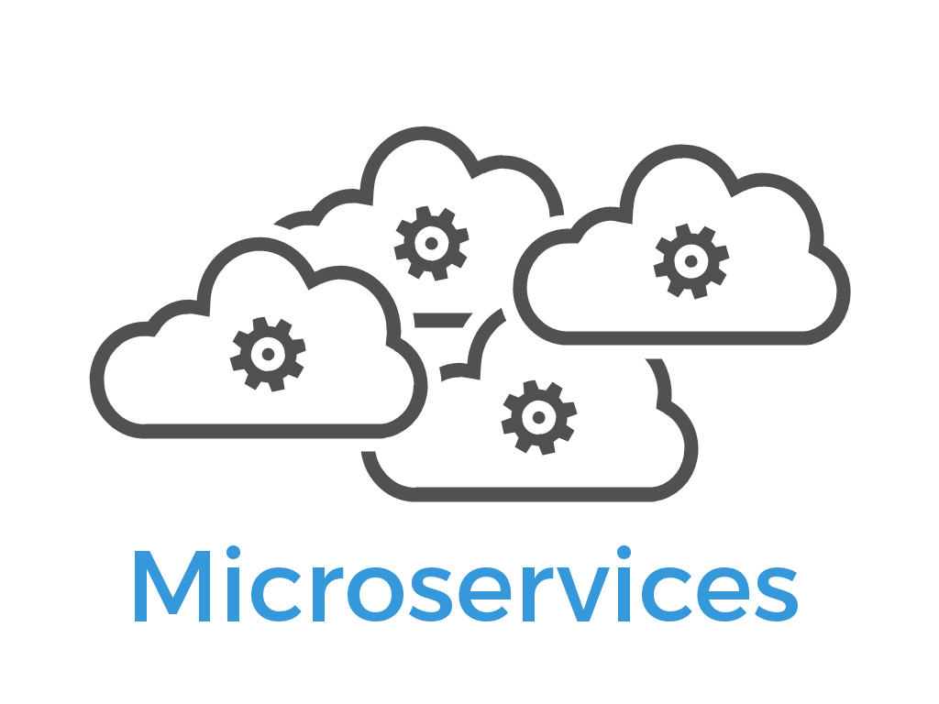 In recent years REST (REpresentational State Transfer) has emerged as the standard architectural design for web services and web APIs. In this module I'm going to show you how easy it is to create a RESTful web service using Python, Flask, Docker and Serverless Containers.

**Module C: Introduction to Linux and Bash**

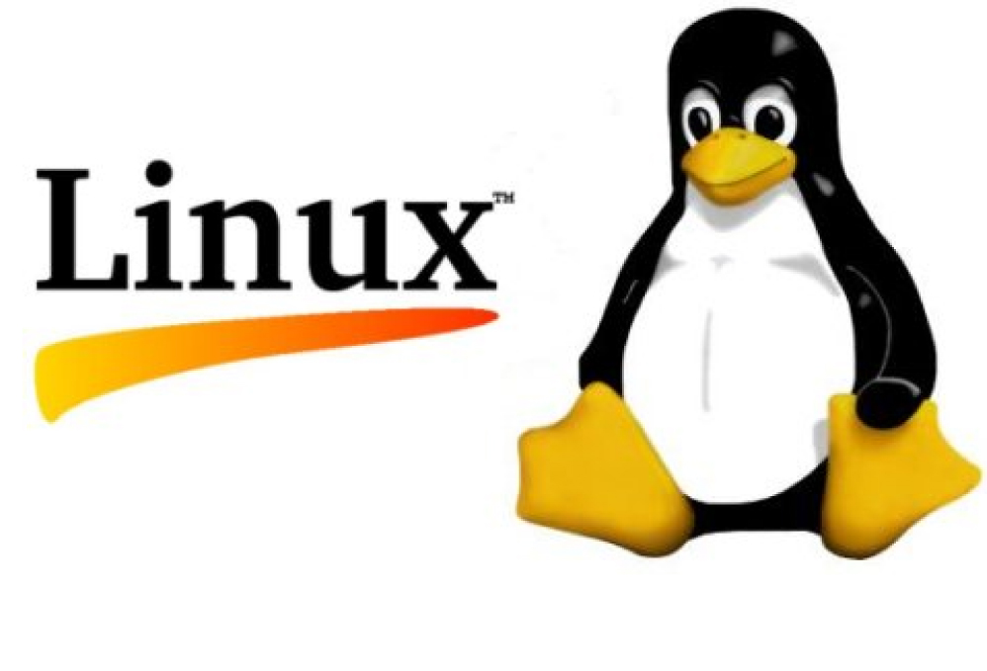 Linux containers are poised to take over the world; we will start our course with an introduction of Linux and the command line. For many non-technical people, the command line (also referred to as CLI, Terminal, bash, or shell) is a place of mystery. However, you only have to know a handful of basic commands to start feeling comfortable. In this module we will cover the basic commands to get you started.

**Module D: Deep Learning in Practice**

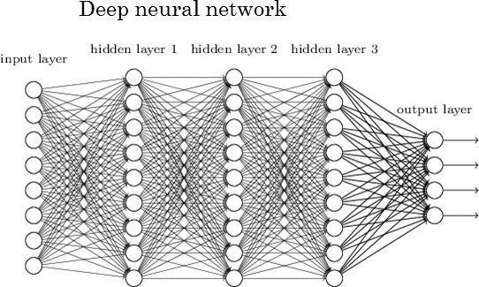This module is structured around a series of practical code examples, demonstrating on real world problems every the notions that gets introduced. We strongly believe in the value of teaching using concrete examples, anchoring theoretical ideas into actual results and tangible code patterns. These examples all rely on Keras, the Python deep learning library. We will cover Deep Learning for computer vision, text and sequences, finance, and advanced neural network design.

**Module E: TensorFlow Eager Execution**

TensorFlow Eager execution is an imperative, define-by-run interface where operations are executed immediately as they are called from Python. This makes it easier to get started with TensorFlow, and can make research and development more intuitive.

**Module F: Build AI Microservices for Serverless Containers Deployments**

In this module we will learn to use Docker, and AWS Fargate to simplify server deployment and use continues integration and deployment strategy. For developing API we will use Flask and REST. If user authentication and storage are required we will use Firebase, which is a backend as a service and its real-time document database Firestore.

**Module G: Deploying and Scaling Deep Learning with TensorFlow, Keras, and AWS Fargate**

In the last module we will learn how to execute these TensorFlow and Keras in production with vision and recommendation models and how to export, package, deploy, optimize, serve, monitor, and test models using Docker, and AWS Fargate.

**Course Outline Semester AI 201:**

|  |  |  |
| --- | --- | --- |
|  | **Topic** | **Learning Material** |
| 0 | Data Analysis | Chapters 4-10 and Projects from Chapter 14  Python for Data Analysis: Data Wrangling with Pandas, NumPy, and IPython, 2nd Edition, by Wes McKinney  <https://www.amazon.com/Python-Data-Analysis-Wrangling-IPython-ebook/dp/B075X4LT6K/ref=sr_1_1> |
|  | Building a data science portfolio | <https://www.dataquest.io/blog/data-science-portfolio-project/>  <https://www.dataquest.io/blog/how-to-setup-a-data-science-blog/>  <https://www.dataquest.io/blog/data-science-portfolio-machine-learning/>  <https://www.dataquest.io/blog/build-a-data-science-portfolio/>  <https://www.dataquest.io/blog/how-to-share-data-science-portfolio/> |
| 1 | Developing Web Applications with Python using Flask | Flask Web Development: Developing Web Applications with Python 2nd Edition  <http://shop.oreilly.com/product/0636920089056.do>  <https://github.com/miguelgrinberg/flasky> |
| 2 | Deep Learning REST API | <https://blog.keras.io/building-a-simple-keras-deep-learning-rest-api.html>  <https://github.com/jrosebr1/simple-keras-rest-api>  <https://www.pyimagesearch.com/2018/01/29/scalable-keras-deep-learning-rest-api/>  <https://www.pyimagesearch.com/2018/02/05/deep-learning-production-keras-redis-flask-apache/> |
| 3 | What is a Container | Lesson Two: Building the Containers with Docker  <https://www.udacity.com/course/scalable-microservices-with-kubernetes--ud615>  <https://www.youtube.com/watch?v=EnJ7qX9fkcU> |
|  | Benefits of Containers | <https://www.youtube.com/watch?v=cCTLjAdIQho> |
|  | Container Registry | <https://www.youtube.com/watch?v=76rX4s73MrM> |
|  | Creating Docker Images and Containers | <https://medium.com/@sachin.abeywardana/docker-for-data-science-4901f35d7cf9>  <https://www.analyticsvidhya.com/blog/2017/11/reproducible-data-science-docker-for-data-science/>  Chapters 1-7, Docker Deep Dive by Nigel Poulton |
| 4 | Containerizing an App | Chapter 8, Docker Deep Dive by Nigel Poulton  <https://docs.docker.com/engine/admin/volumes/bind-mounts/#choosing-the--v-or-mount-flag>  <https://medium.com/statuscode/dockercheatsheet-9730ce03630d>  **Quiz One: Docker Deep Dive** |
|  | Chapters 1-7, Linux: Easy Linux for Beginners by Felix Alvaro | Using Linux OS and the Command Line inside a Container |
| 5 | Understanding Microservices | Lesson One:  <https://www.udacity.com/course/scalable-microservices-with-kubernetes--ud615>  Chapters 1, Python Microservices Development by Tarek Ziade |
|  | Introducing Cloud Native Architecture and Microservices | Chapter 1, Cloud Native Python by Manish Sethi |
| 6 | Building React Web Apps using Microservices in Python | Chapters 2-5, Cloud Native Python by Manish Sethi  The Road to learn React: Your journey to master plain yet pragmatic React.js  <https://leanpub.com/the-road-to-learn-react>  Reference: <https://testdriven.io/part-one-intro/> |
| 7 | Using Ngnix in Containers | NGINX: A Practical Guide to High Performance  <https://www.nginx.com/resources/library/nginx-practical-guide-high-performance/> |
| 8 | AWS Fargate and Azure Container Instances | <https://www.youtube.com/watch?v=GJ3S4CEAcJE>  <https://diginomica.com/2018/03/23/aws-lambda-kubernetes-future-serverless/>  <https://hackernoon.com/azure-container-instances-vs-aws-fargate-3216607f63f4>  <https://aws.amazon.com/fargate/>  <https://azure.microsoft.com/en-us/services/container-instances/>  <https://thenewstack.io/the-future-of-kubernetes-is-serverless/> |
|  | Deep Learning Containers | <https://www.nvidia.com/en-us/gpu-cloud/deep-learning-containers/> |
| 9 | Data Science Methodology | <https://cognitiveclass.ai/courses/data-science-methodology-2/> |
| 10-11 | Deep learning for computer vision | Chapter 5, Deep Learning with Python by François Chollet  **Quiz Two: Deep Learning for Computer Vision** |
| 12-13 | Deep learning for text and sequences | Chapter 6, Deep Learning with Python by François Chollet  **Quiz Three: Deep Learning for Text and sequences** |
| 13-15 | Advanced neural network design | Chapter 7, Deep Learning with Python by François Chollet  **Quiz Four: Advanced Neural Network Design** |
| 16-17 | Generative deep learning | Chapter 8, Deep Learning with Python by François Chollet  **Quiz Five: Generative Deep Learning** |
| 18-19 | TensorFlow Eager Execution | <https://github.com/tensorflow/tensorflow/tree/master/tensorflow/contrib/eager>  <http://web.stanford.edu/class/cs20si/lectures/march9guestlecture.pdf>  <https://docs.google.com/presentation/d/1e1gE2JJXipWm1UJgor_y8pHcM8L8oMaCVtvQvZUBlQY/edit#slide=id.g2f12664f01_0_0> |
| 20 | A Brief Introduction to PyTorch | <https://pytorch.org/> |
|  |  | **Project: Build a Crypto Graphics Web AI App using Microservices, React, TensorFlow/Keras and MPLD3**  <http://mpld3.github.io/> |

**Text Books:**

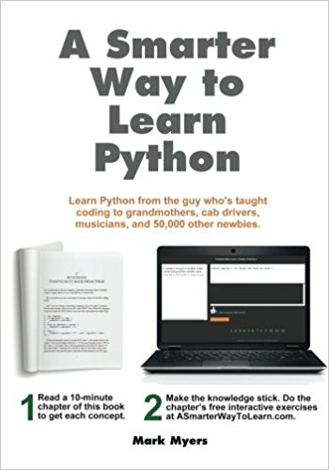

1. A Smarter Way to Learn Python by Mark Myers

<https://www.amazon.com/Smarter-Way-Learn-Python-Remember/dp/1974431479>

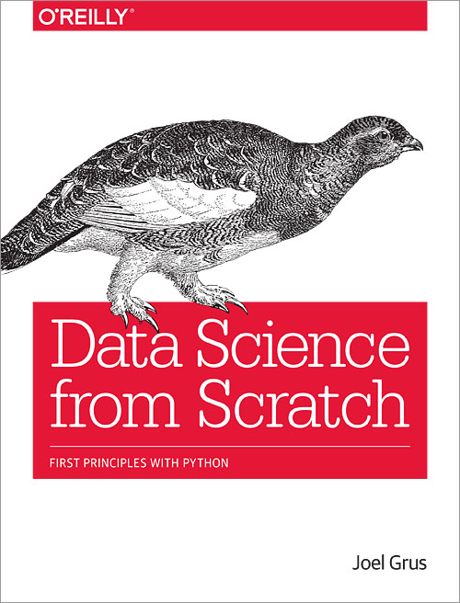

1. Data Science from Scratch by Joel Grus

<http://choonsiong.com/public/books/Data%20Science%20from%20Scratch.pdf>

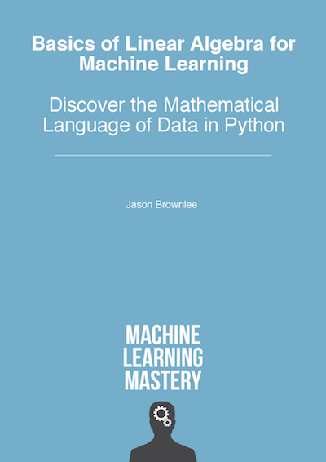

1. Basics of Linear Algebra for Machine Learning by Jason Browniee

<https://machinelearningmastery.com/linear_algebra_for_machine_learning/>

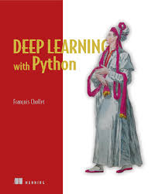

1. Deep Learning with Python by Francois Chollet

<https://www.manning.com/books/deep-learning-with-python>

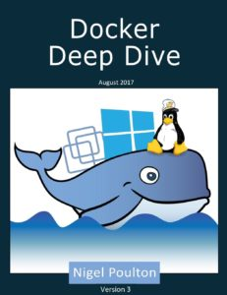

1. Docker Deep Dive by Nigel Poulton

<https://www.amazon.com/Docker-Deep-Dive-Nigel-Poulton/dp/1521822808/ref=sr_1_1>

1. Probability and Statistics Crash Course

<https://docs.google.com/file/d/0BzVk8fxj9agkVGlBWEVrMlRvaGs/edit>

1. 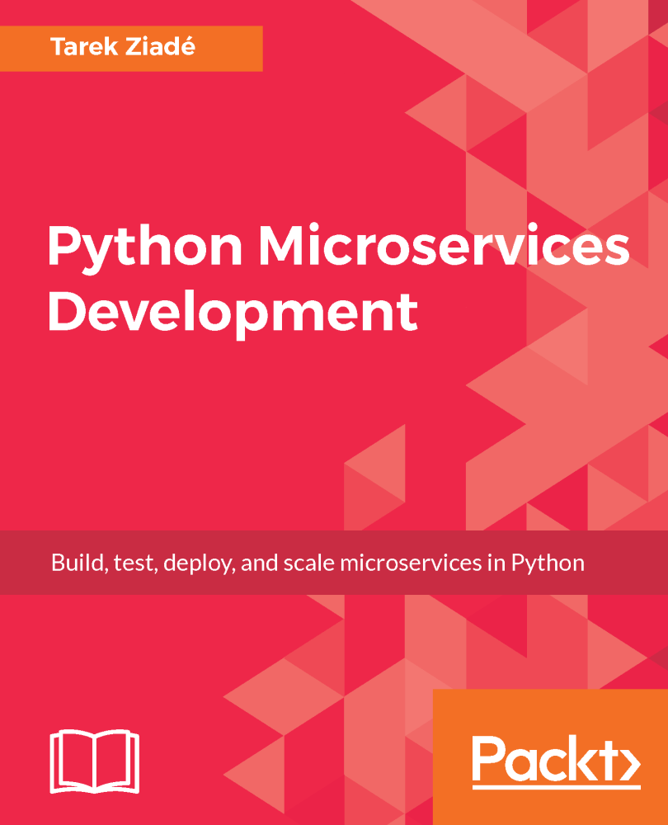Python Microservices Development by Tarek Ziade

<https://www.amazon.com/Python-Microservices-Development-deploy-microservices-ebook/dp/B01N7N7BU9/ref=sr_1_1>

1. Learn Version Control with Git: A step-by-step course for the complete beginner by Tobias Günther

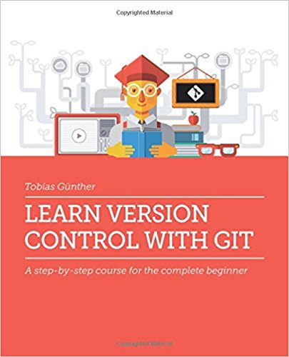

1. 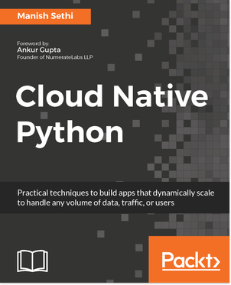 Cloud Native Python by Manish Sethi

**Reference Material:**

1. Deep Learning: Take machine learning to the next level

<https://www.udacity.com/course/deep-learning--ud730>

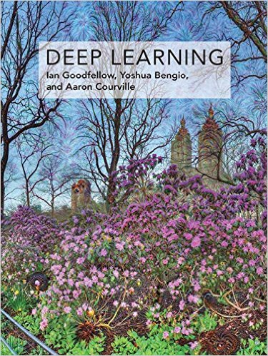

1. Deep Learning (Adaptive Computation and Machine Learning series) by Ian Goodfellow, Yoshua Bengio, Aaron Courville

Free Web Book: <http://www.deeplearningbook.org/>

1. 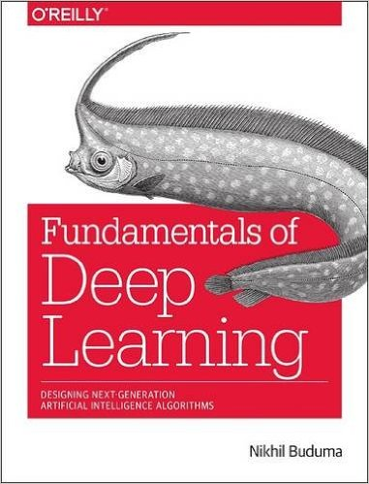Fundamentals of Deep Learning: Designing Next-Generation Machine Intelligence Algorithms by Nikhil Buduma

<http://shop.oreilly.com/product/0636920039709.do>

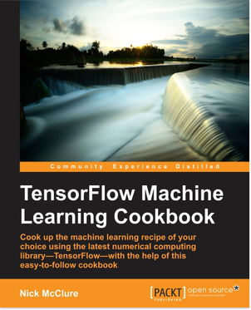

1. TensorFlow Machine Learning Cookbook by Nick McClure

<https://www.packtpub.com/big-data-and-business-intelligence/tensorflow-machine-learning-cookbook>

**The Teaching Team:**

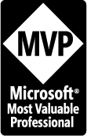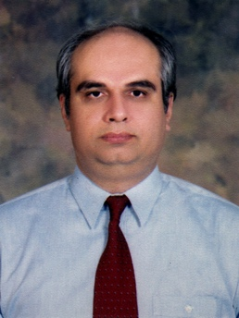**Mr. Zia U. Khan** (http://www.facebook.com/ziakhan.edu) will be the co-instructor for this course. He is the CEO of Panacloud (Pvt.) Ltd. He has fifteen years of experience in teaching computer science subjects and has extensive experience in development of business and financial software solutions. For eight consecutive years, in 2007, 2008, 2009, 2010, 2011, 2012, 2013 and 2014 he has received the Most Valuable Professional (MVP) Award from Microsoft USA. He has a Master of Science in Engineering (MSE), Master of Business Administration (MBA), and Master of Accountancy (MAC) in MIS, all three from Arizona State University. He is also a CPA and CMA in USA.

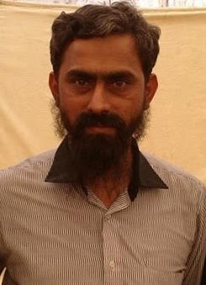

**Mr. Inam ul Haq** is the CTO of Zaavia and has over a decade of software development and teaching experience. He will be the co-instructor for this course. He is the academic supervisor of Saylani Mass Training Program, which is teaching computer science to thousands of students completely free of cost.

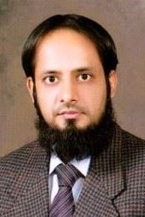

**Dr. Noman Islam** Associate Professor at Iqra University

**Mr. Anees Ahmed**, more than ten years of experience in Databases and Data Analysis

**Mr. Khurram Raheel Meher** is a Senior Developer at Panacloud and Senior Teacher at Saylani Faisalabad

**Dr. Muhammad Gufran**, Assistant Professor at FAST-NUCES Faisalabad



**Mr. Nasir Hussain**

He has a Masters in Computer Science from University of Karachi UBIT. He also has over ten years of experience in working with different software houses and banks.